Confessions of the Starving Artist
"Confessions of the Starving Artist" - 3/13/08

I know what life's about
I know you have your doubts
I never had it figured out
Like I do tonight

A band is born.

Friday night, March 7, the wind blew and the rain poured down
and three intrepid souls named Thieves and Poets made their way
from New Jersey to City Island to play the Starving Artist Cafe.
These three guys brought four guitars and a very impressive percussion
rig. They played an eclectic mix from the Rascals to Hendrix to Mingus
and originals. Wow! Using both acoustic and electric guitars, Bill Irvine
and George Kelly showed beautiful jazz chops. Chris Frawley on
percussion was a thing to behold - cymbals, wind chimes, triangle,
bongos, shakers and a djembe (sometimes played with brushes),
keeping everything in the pocket in a tasty way. They will definitely
be back. Watch for them.

Saturday night, 3.08.08, was a great night, grand night for me. I took
the stage and played two long sets. It was an evening packed with
surprises (even to me). The first set was a solo acoustic set, running
through eight of my own tunes and two covers, ending with "Bitter
Tears" on Neil Young's Living With War web site. I'm a pretty
lucky guy and my blessings are many. The house was packed - I mean
really packed. In the audience were friends who would be coming on
stage for the second set. First came my good friends from
Project Mercury, Craig and Jeanne Fox. I had e-mailed a lyric sheet
with chords and they learned the harmony and wrote a beautiful cello
part. They joined me on "Like I Do Tonight." That performance alone
is worth the price of the DVD. (Visit www.youtube.com/elliottglick to see that video.)

I love these people even more now. Next was my beautiful wife Monica joining me on "Hallelujah." She tore up that song like she was testifying. I was then joined by a former guitar student of mine. James McGowan created a raucous swing jam out of our heads. This high school kid has already played with the likes of Dave Matthews on the Today Show. Another former guitar student stepped into the lights to play the rest of the evening with me. Evan Berent is a good guitar player. We did "Love Me Girl" and a few other of my originals. We were then joined by Joe Bruno on drums and Seth Okrend on bass. I only rehearsed once with each of them and never all together. In fact, Seth said when I introduced the band, "He means REALLY introduce the band." Up came the mysterious Dr. D on blues harp. He's a wild man on harp. We jammed on an old chestnut and brought it back to life for awhile (instrumental defibrillation). We played a few more originals and said good night to a cheering crowd who called for more. The encore was "I've Been Told," the title song from my CD. I had the time of my life and so much love and goodwill from so many people - Jorge Caraballo (of Freakin' Rican and Rubber Soul fame) and Anna Foster, Marian Mastrorilli (of Project Mercury), Bob "Big Folkie" Kresse, Bob and Mary Lou Lachman, Frank and Cheryl Koller, Marc Hohenstein, Ellen Ruth Topol, Ann and Jack Jaffe, Cheryl and Bob Berent, Rabbi Shohoma, Olga, Max, Gene Fine and his family, and the list goes on and on. Uncle Bill cooked for the crazy large crowd. Thank you and thanks to Mariel and Monica for letting me do my thing. They're the best! And I thank everyone there once again!

Sunday is a time to chill out and listen to some jazz in the afternoon and that's just what we did on Sunday, March 9. Our own City Island Jazz Quartet put the sun in Sunday. Cool fluid solos played against the jazz standards. Even a couple of basso novas were thrown in the mix. The band is Roger Scala on sax, Gene Zilempe on electric bass, Sal Mazzola on drums and the legendary sideman, studio man and soloist Lou Volpe. Lou is a songwriter as well. He is featured on Guitar Player Zen Web Site. Read his article. It's a seminar for free. Well, they cooked up another great afternoon. I got to sit with a glass of wine and listen for awhile.

Well, click the links to everyone. "Click on Glick" at Neil Young's Living With War Web Site (#102 - Baby This One's For You; #104 - Bitter Tears). Click on the calendar for this weekend's artists - they're great, I promise - and celebrate St. Patrick's Day with us Sunday! Most of all, come in, and live right!

Elliott Glick

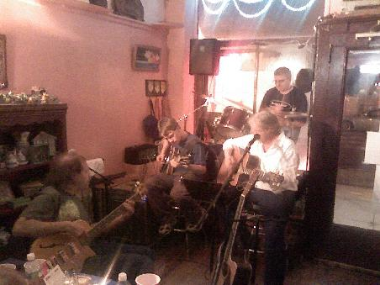
The Elliott Glick Band made its debut at the Artist on Saturday, March 8. (Photograph by "Uncle Bill" Yehle)

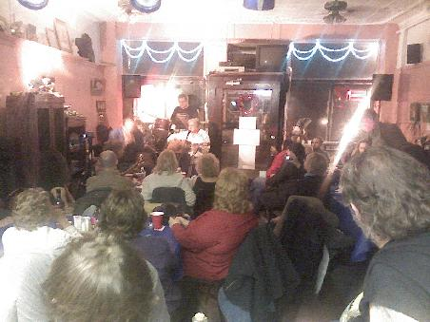
Glick played to a packed house - a standing room only crowd, in fact - on Saturday, March 8
(Photograph by "Uncle Bill" Yehle)

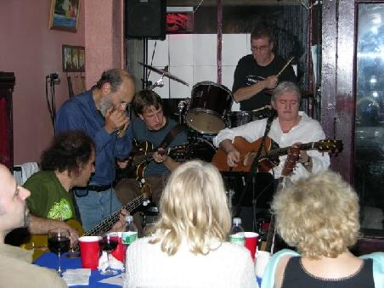
The Elliott Glick Band - Joe Bruno (drums), Seth Okrend (bass guitar), Evan Berent (lead guitar) -
are joined by Dr. "D" on harmonica. (Photo by Bob Berent)

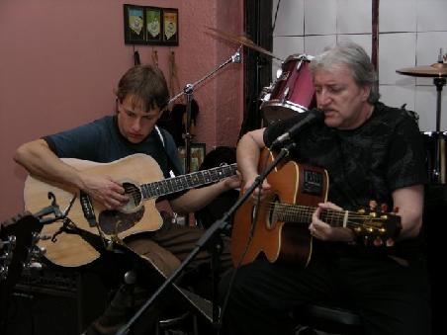
Glick performed several songs with Evan Berent on lead guitar; Berent, a member of the Elliott Glick Band,
was also Elliott Glick's guitar student at one time. (Photo by Bob Berent)

