Confessions of the Starving Artist
1/21/08
There must be guitars
Life is there for us to live
Come in and live right

You’ve got to love a weekend like this. We had two of the best guitar players anywhere. Friday night,
January 18, at SAC&G, John Guth took the stage. From the first notes you knew this guy could play.
John is a fine songwriter as well. He covered songs by the likes of Richard Farina. John played with
Richard’s widow Mimi (Joan Baez’ sister) on a couple of tours. Look up Richard and Mimi Farina.
John has played the Starving Artist as backup to his friends. This is the first of his solo engagements
at the Artist. He played a rousing rendition of Johnny B. Goode, and he was.

So how do you follow a good guitar player? With another one. Saturday, January 19, the Lou Volpe
Starving Artist Jazztet took the stage. First, it’s an honor to have this really hot jazz band use that name.
If you’ve never heard Lou Volpe play guitar, get to CD Baby right now. Forget Clapton and those guys,
Lou is pure guitar. Notes fly in a fluid flurry from his guitar like a beautiful fireworks show. Lou has
played the Artist perhaps more than anyone. With the City Island Quartet, solo and with his Jazztet.
He’s even played with me in my sets. I’ve covered him in these blogs numerous times. I think I like
the Volpe Jazztet thing the most. James Rococa and John Clay, on bass and drums respectively,
match him well and keep it all right in the pocket. Check out Lou’s originals; they’re great.

Bluesabilly. There I’ve said it. That’s what we had on Sunday afternoon, January 20 in the form of
the NYC Blues Trio. Erica Johnson is someone who happens to work with my wife. I had no idea
she played music at all. Well, here she was at SAC&G with two guys playing bluesabilly. I swear
bandmate Richard Chambers channeled Johnny Cash. You guessed it. They played the blues in a
purist style and rockabilly also with a purist sensibility. Erica even sang an original. She switched
from bass to six string flat top to sing a song about the Bronx. Well, specifically Co-op City and
the Starving Artist on City Island (two honors in one weekend!). This band of really nice people
which also included Mark Freese (and their really nice guitars) sang the sun to sleep and as evening
fell we all sat down to spaghetti and meatballs. Speaking of Italian food, next week I will be in Italy.
There’ll be plenty to blog about then.

Do the right thing. Support live independent music. Click all the links to these awesome musicians.
Click on Glick at the Neil Young Living With War web site - now #92 and #94. Keep warm, and
come in, and live right.
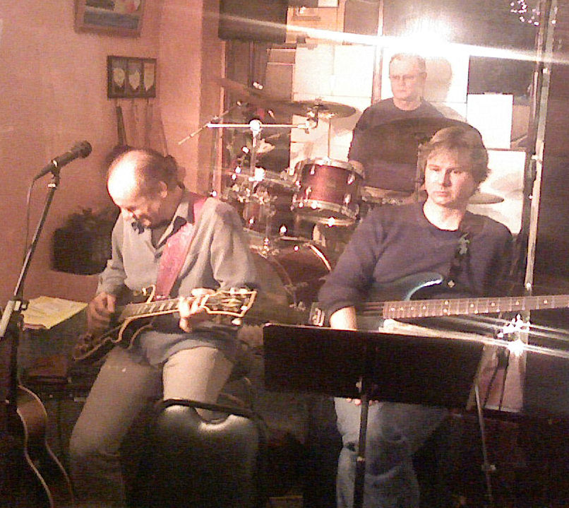

Elliott Glick
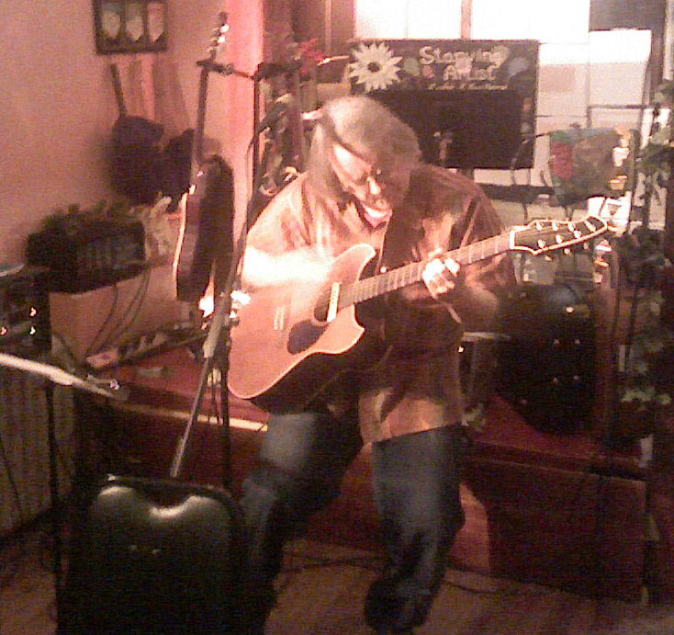

(left to right) John Guth, Lou Volpe and his Starving Artist Jazztet, and
NYC Blues Trio (photos by “Uncle” Bill Yehle)

